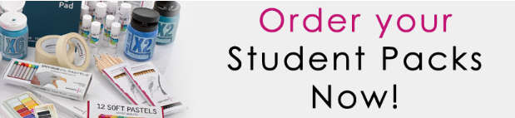

Balcarras Art department offering students who are studying Art at A Level the opportunity to purchase an “Art Pack”. The pack will contain the basic, but necessary equipment with which to support student’s coursework, both in and out of school.
COVID: Given the current situation we feel it very important that pupils have access to their own equipment as far as possible, enabling us to cut down on the amount of shared equipment that pupils will come into contact with.
Pupils not purchasing an art pack will need to provide, or have access to basic equipment of their own.

ITEM
A3 Seawhite Storage Box (for safe packing)
Medium Acrylic Paint set (10x75ml)
Brush Set Sizes (2.4.8.10)
Black Fineliner Set 4
Glue stick 40g
Masking tape
Pentel White Gel Pen
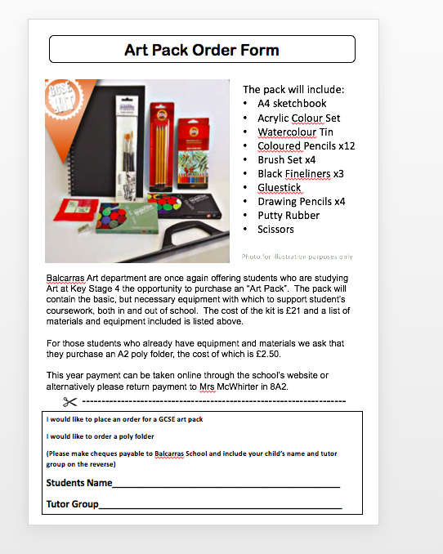

For illustration only

Payment should be made online through the school’s website
DEADLINE FOR PAYMENT: MONDAY 14th SEPTEMBER

--------------------------------------------------------------------
I would like to place an order for a ALevel art pack and enclose cheque to the value of £20 (Please make cheques payable to Balcarras School)
Students Name____________________________________________
Tutor Group_______________________________________________

